SURPLUS LAND BID PROCESS

- Initial bids for Surplus Property parcels are to be submitted on the Surplus Land for Sale webpage, using the “Submit a Bid Here” link located on the right-hand side of the Surplus Property Table, which is found at the bottom of the Surplus Land webpage (see example below).

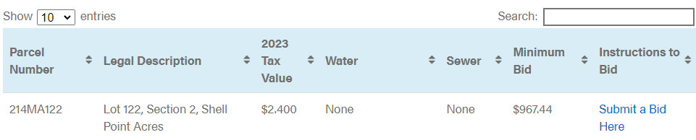

  - The minimum bid amount for each surplus parcel is listed in the table.

    - All initial bids must be at least the minimum bid amount, or higher.

- Initial bids are sorted approximately once per week to determine the highest bidder.

  - The highest bidder will receive an email with instructions on paying the deposit for their bid.

    - No action is to be taken and no deposits are to be paid until this email is received.

  - The parcel will remain in the table on the surplus land webpage until the deposit is received from the highest bidder.

    - Any parcel waiting on a deposit will be labeled as “Tentative Initial Award – Pending Deposit” in the STATUS column of the table.

      - Other bids may still be submitted for a surplus parcel that is pending a deposit, but the original high bid offer will be honored if the deposit is received, regardless of whether a higher bid is received while the deposit is pending, and the any other bids received during the tentative period will be discarded.

    - If the original high bidder’s deposit is not received in a reasonable timeframe, the parcel’s pending status will be changed to “Accepting Bids” and a new high bidder will be selected when the bids are sorted the following week.

- Once the bid deposit is received by the county, the parcel is removed from the online Surplus Property Table and a notice for the ”Upset Bid Period” is posted to the surplus property webpage under the heading CURRENT NOTICES OF UPSET BID PERIOD.

  - Notices of Upset Bid Period are also published in the Brunswick Beacon and State Port Pilot newspapers.

    - The cutoff date for newspaper notices is Wednesday each week, if the deposit is received by noon on Wednesday the Notice of Upset Bid Period will be published in the following week’s publications. If the deposit is received past noon on Wednesday, the Notice of Upset Bid Period will be published two weeks later.

- Information on the Upset Bid Period can be found on the Surplus Land for Sale webpage.

